Retro Bytes - User Guide
This guide explains how to use the Retro Bytes application: first-time setup, feature walkthroughs, scenarios, troubleshooting, and how security affects the user experience.

1. Getting Started
- Launch the app (see Build & Setup Guide) and open http://localhost:8081/ (current port).
- Use the header to navigate: Home, Categories, Search, Cart, Wishlist, Orders (when logged in), Admin (for admin only), Login/Logout.
- When entering ZIP codes for testing, use 20742 or 10001.
- Users:
alice@retrobytes.test / Passw0rd!
bob@retrobytes.test / Passw0rd!
luke@retrobytes.test / Passw0rd!
yoda@retrobytes.test / Passw0rd!
- Admin:
admin@retrobytes.test / Passw0rd!

2. Features Overview
- Browse categories and product details (price, condition, images).
- Check local stock by ZIP (5-digit).
- Search by keyword, filter by category and condition.
- Cart and checkout: add items, view totals, place orders, view order confirmation.
- Wishlist: save/remove items per session/user.
- Admin (for ADMIN role): manage inventory, orders, and users.
- Order history (logged-in users): /orders.

3. Use Cases (Step-by-Step)
UC-1 Browse Catalog
- From Home, click a category (e.g., Retro Consoles), click a product to view details.
UC-2 Check Local Stock
- On a product page, enter ZIP (e.g., 20742) → Check → see In/Low/Out of stock and qty.
UC-3 Add to Cart & Place Order
- Product page → Add to Cart → Cart → Checkout → enter name/email/ZIP, choose delivery/pickup → Place Order → redirected to /order/{id} with details.

UC-4 Search & Filter
- Search page → enter keyword → Apply and optionally choose Category/Condition → Apply → open product.
UC-5 Wishlist
- Product page → Save to Wishlist and view/remove items via /wishlist.
UC-6 Order History (logged-in)
- After login, use Orders link → /orders to see your orders and view details.
UC-7 Admin (ADMIN only)
- Use Admin link → manage orders (cancel/update), inventory (edit qty), users (delete non-admin users. their orders are canceled but retained).

4. Screenshots
Home (categories)
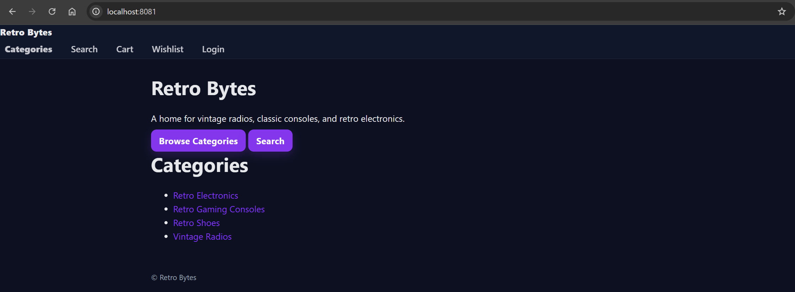
- Category (grid)
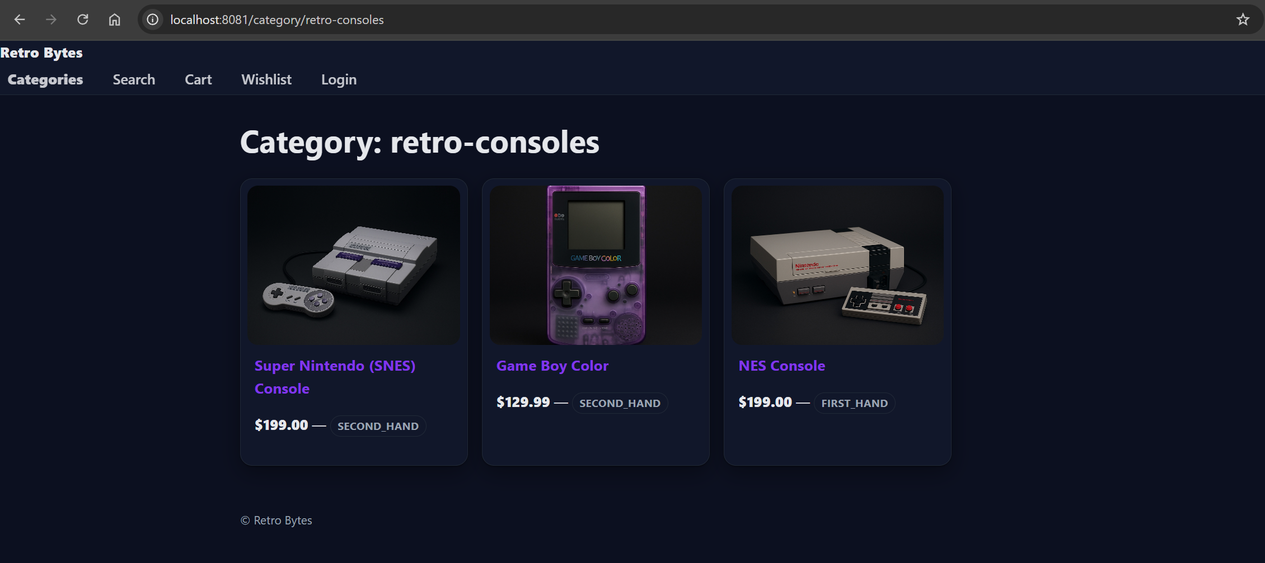

- Product
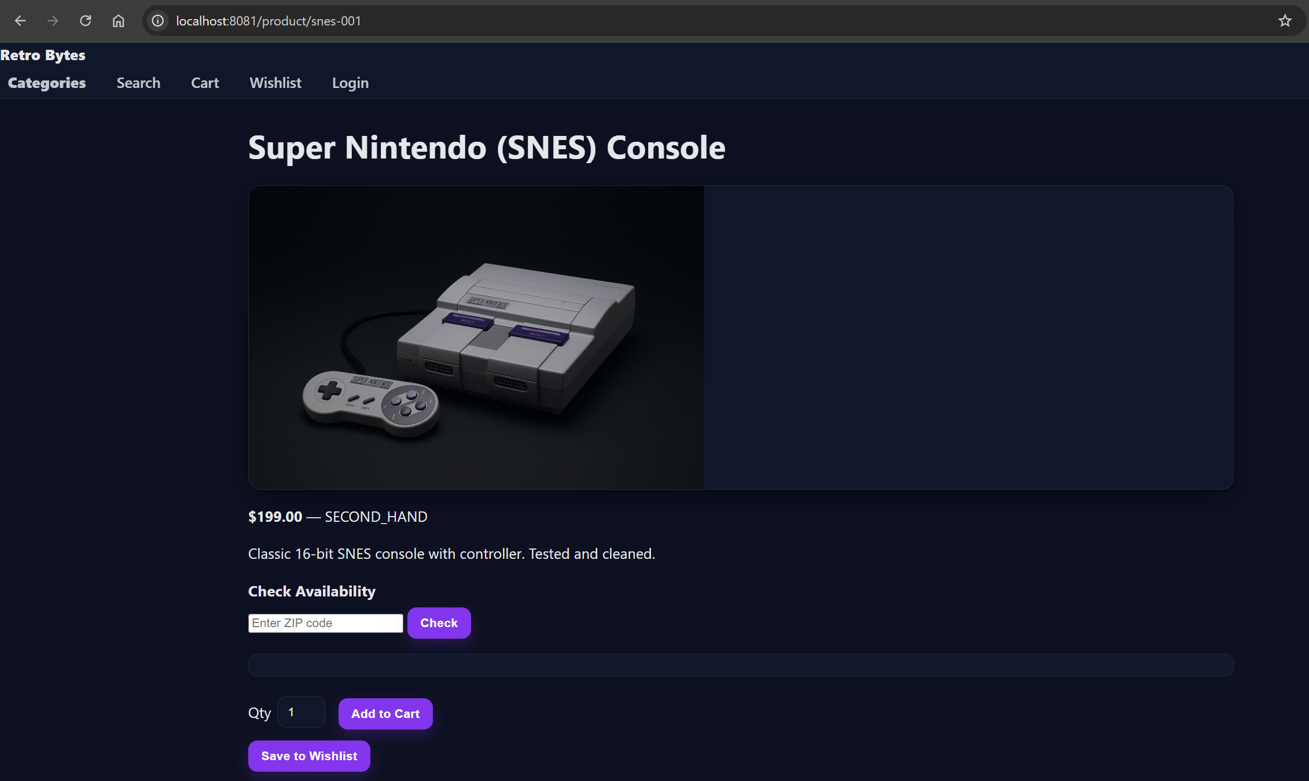
- Availability check
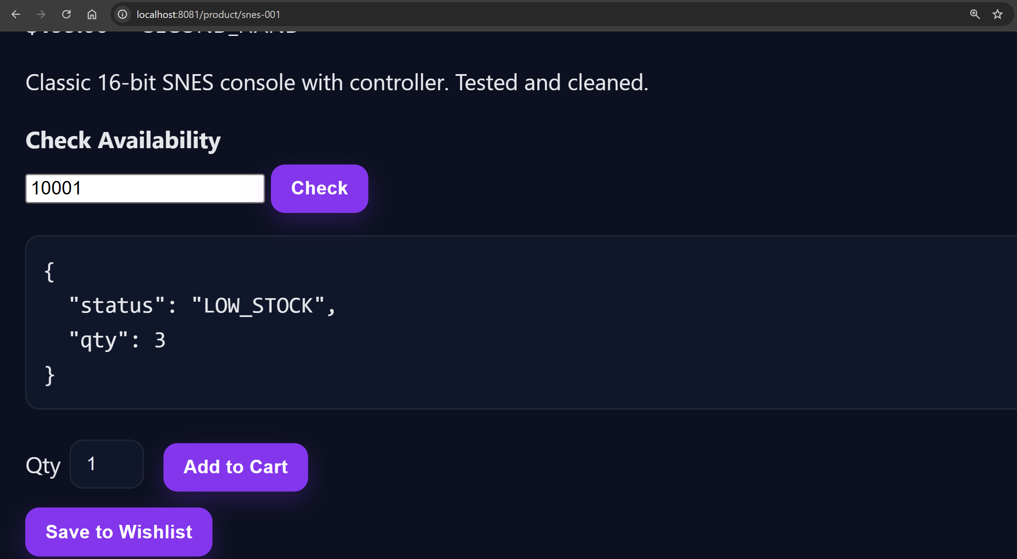

- Cart
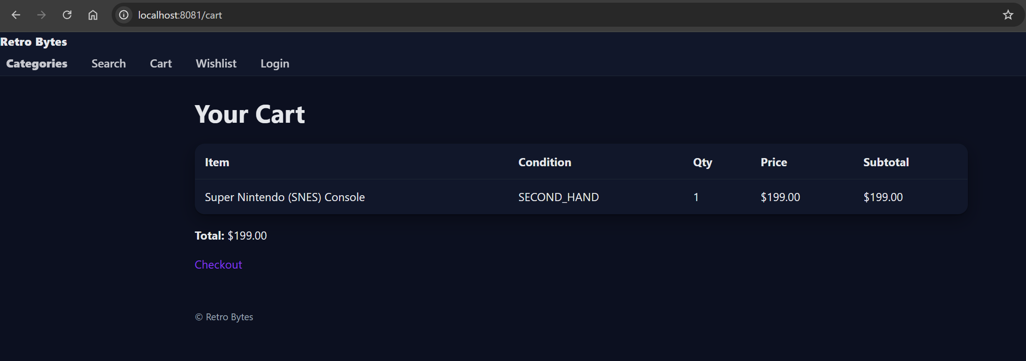
- Checkout
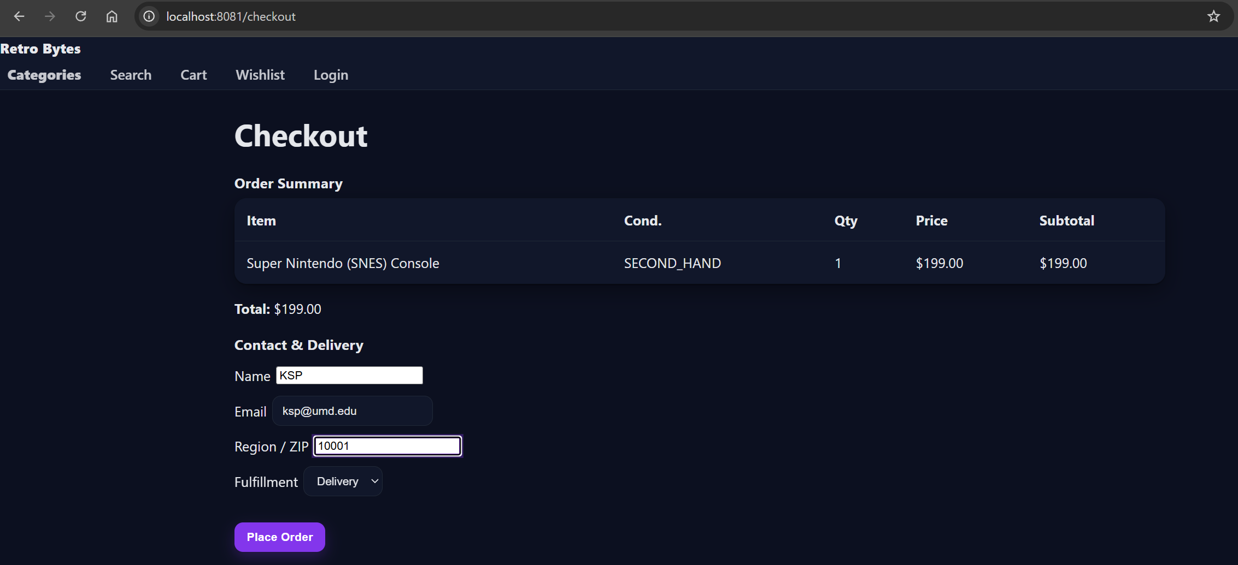
- Order confirmation
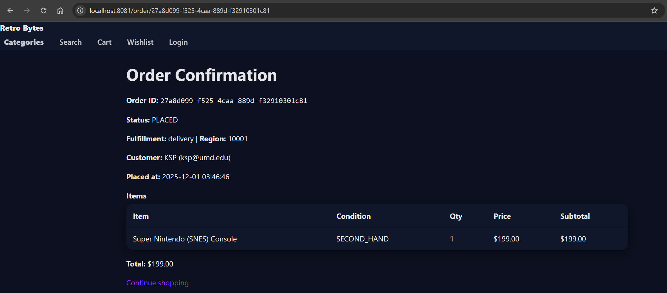

- Wishlist
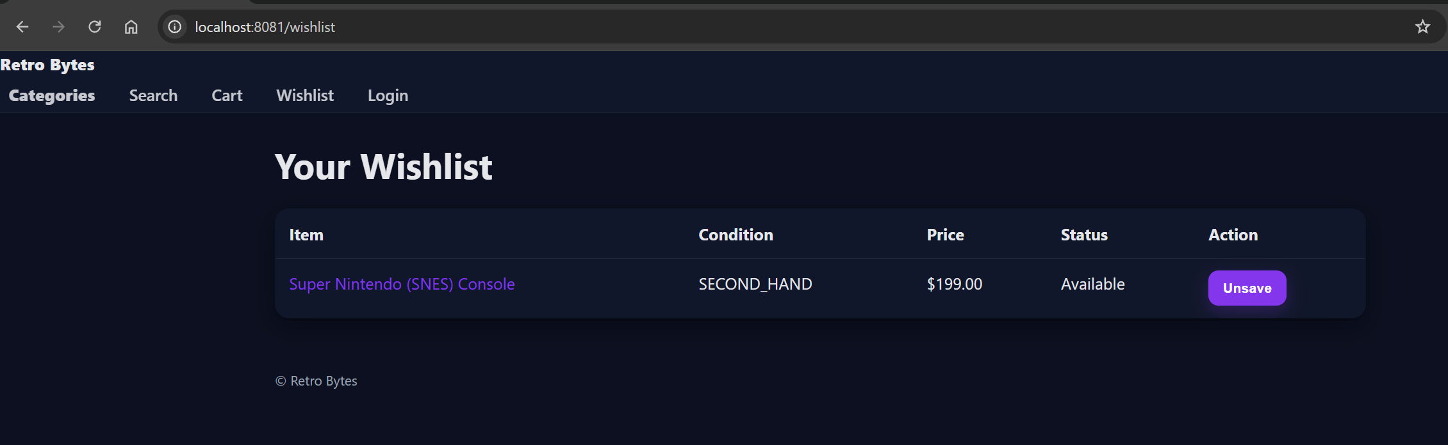
- Search results
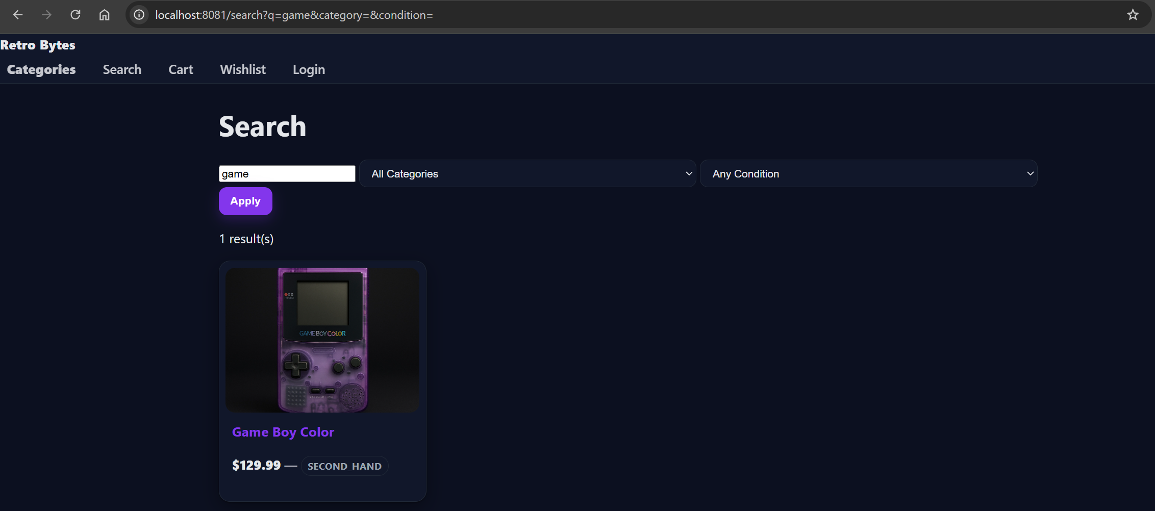

- Login Page
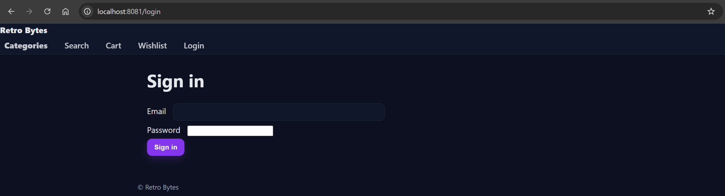
- Admin
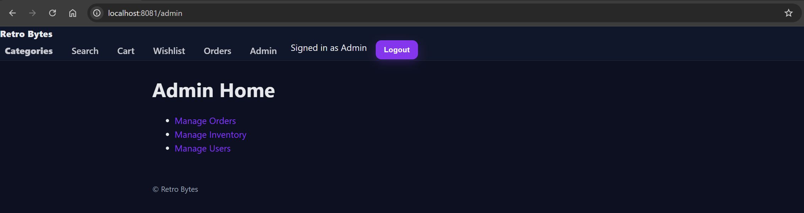
- Admin Inventory
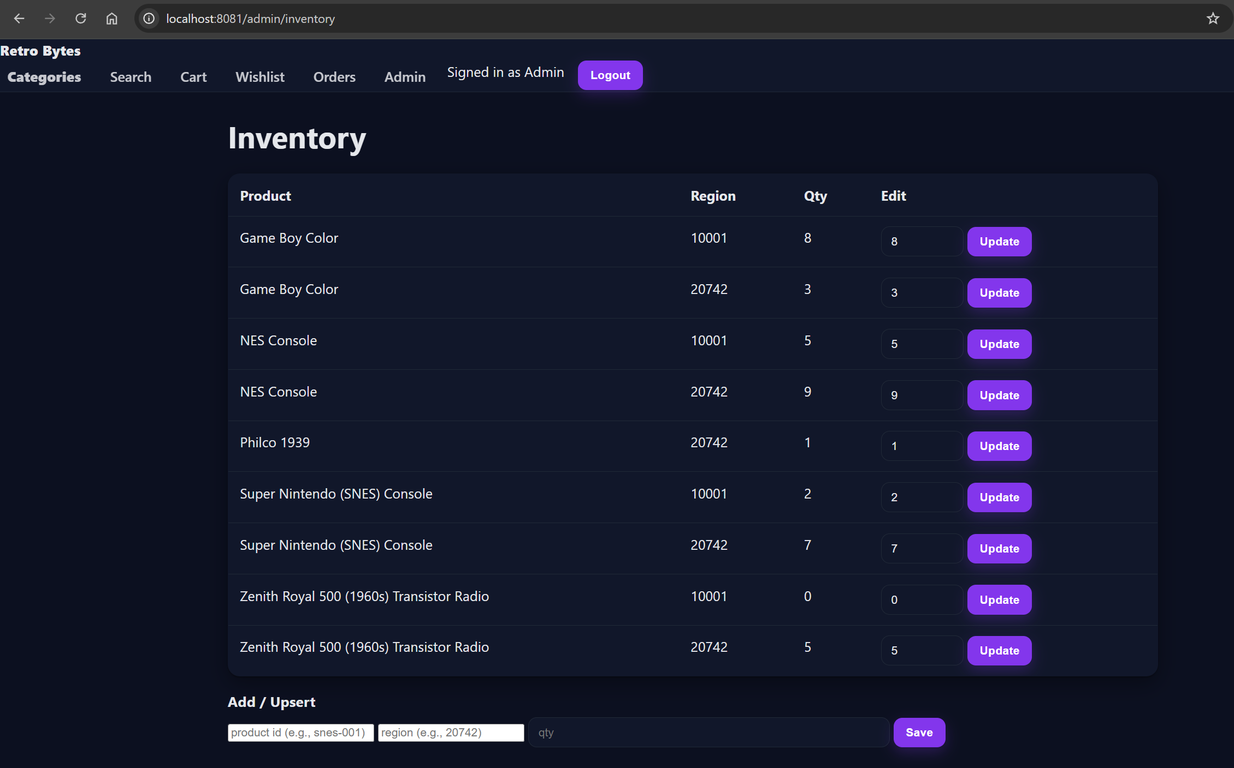
- Admin Managing Users
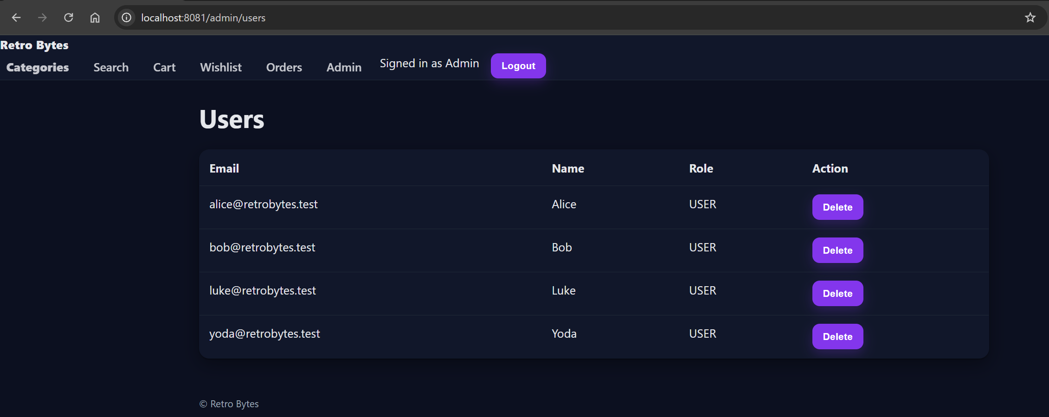

5. Troubleshooting (User-Facing)
- Invalid ZIP/search: enter a 5-digit ZIP and search only allows letters/numbers/space/’/- and max 50 chars.
- Order placement fails: ensure valid name/email/ZIP and item must be in stock and cart total item cap is 10.
- 429 Too Many Requests: wait for rate limit to reset (search/availability/login).
- CSRF/403: refresh the page to get a fresh token and ensure cookies enabled.
- Missing images: ensure media exists under web/media/products/<id>/main.jpg.
- Admin access denied: only ADMIN role can open /admin and log in as admin@retrobytes.test.

6. Security Features (User Impact)
- Inputs validated (ZIP, search, name/email/password, IDs, qty) and bad inputs return friendly 400s.
- Login protected by throttling, passwords stored hashed (bcrypt) and session cookie is HttpOnly, SameSite=Lax.
- Orders recompute totals server-side, tampered client prices/qty are ignored and stock enforced at checkout.
- Wishlist/cart scoped to your session/user and admins cannot view others’ wishlists.
- Media served from a fixed root and traversal attempts blocked (raw/encoded).
- Errors are friendly - internal details logged server-side.
- Logging: auth success/fail, access denials, rate limits, order totals (server vs client), admin inventory/user actions, CSRF failures, server errors.

7. Notes
- Session cookies keep cart/wishlist/order access and logout clears user binding.
- Use HTTPS in production and set cookies Secure and session rotation/expiry can be enabled in deployment.

